 | Student Name _______________________  Eastern Goldfields College  Unit 3 Essential Mathematics 2016  Mental Skills Test 1
 | Time: 10 minutes Total Marks: 50 marks
CALCULATORS NOT ALLOWED
1. A rectangular has a perimeter of 18cm. State a possible width and length.  1 and 8, 2 and 7, 3 and 6, 4 and 5 | 9. 45cm³ = ml  45ml
2. Calculate the area:  15m  10m  75m² | 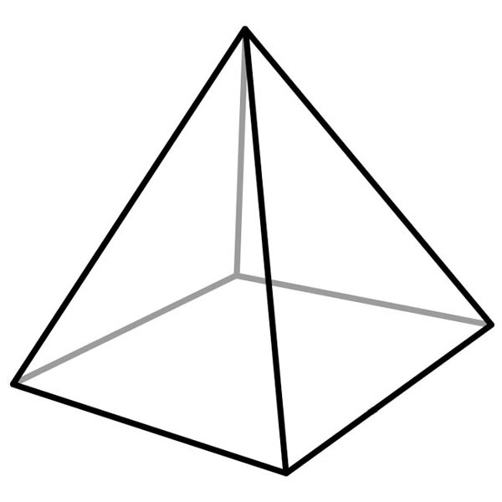  10. Find the volume:  3cm  3cm  2cm 6cm³
3. 5cm² = mm²  500mm² | 11. What is the capacity of the cube?  1000ml
4. Name an area in ‘real life’ measured in m².  Any reasonable answer | 12. Surface area of a cube with side length 5cm  150cm²
5. 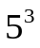  125 | 13. What units would you use to measure the capacity of a rainwater tank?  L or kL
6. How many millilitres in 1 kilolitre?  1,000,000 | 14. Each shape is made up of 5 cubes. Which has the greatest surface area?  They are the same
7. Find the area:  7cm  6cm  11cm  54cm² | 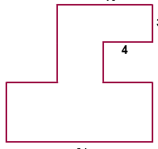  15. How much fencing is needed to completely fence in the paddock? Give answer in km.  100m  70m  30m  0.46km  30m  100m  30m
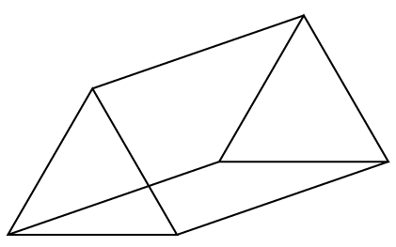
8. Name this shape.
Triangular prism

